|  |  |
| --- | --- |
| Stella Nova Logo | LOGO4 |
| Best Buy Canada Mobile | |
| |  | | --- | | **Inventory Lookup Feature Document** |   **Document Version: 1.3**  **Design Date: October 8, 2012** | |
| **Prepared By: Amy Lackas** | |
|  | |

**Table of Contents**

*1.* *Feature Overview* 3

1.1 Feature Description 3

1.2 Assumptions 3

1.3 Parameters and System Settings 3

1.4 Interfaces 3

*2.* *USE CASE: Inventory Lookup* 4

2.1 Feature Flow 4

2.2 Precondition 4

2.3 Main Flow 4

2.4 Alternate Flows 4

2.5 Post Condition 5

2.6 Special Requirements 5

*3.* *Supplemental Specifications* 5

3.1 Electronic Journal 5

3.2 Modify Transaction 5

3.3 Operator Sign On 5

3.4 POSLog 5

3.5 Printed Receipts 5

*4.* *Screen Layouts* 6

4.1 Inventory Lookup Details 6

*5.* *Business Sign Off* 9

*6.* *Revision History* 9

*7.* *Appendix A: Glossary* 9

*8.* *Appendix B: Referenced Documents* 9

# *Feature Overview*

## Feature Description

The Inventory Lookup feature allows the operator to retrieve inventory details for an item at a store.

## Assumptions

1. If the Inventory Lookup application is launched from Operator Sign On screen, the system does not prompt for sign on credentials.
2. If the Inventory Lookup application is launched from Modify Transaction once a transaction has started, the operator is able to return to the transaction once the operator exits from the Inventory Lookup application without having to sign back into the application.
3. All text displayed by the system is configurable by brand to support multi-language.  Text is defined from an external source or defined within the system.
4. All Manager Overrides are bypassed.

## Parameters and System Settings

|  |  |  |
| --- | --- | --- |
| **Parameter Mnemonic** | **Description** | **Valid Values** |
| None |  |  |

## Interfaces

|  |  |
| --- | --- |
| **Interface** | **Description** |
| Get Inventory Details Service | The external service that is called to retrieve the inventory details for an item at a given store. |
| REST API: Search Service | The external service that retrieves items based upon the search criteria. |
| REST API: Product Service | The external service that retrieves product details (descriptions, model number, image), customer rating. |
| REST API: Locations Service | The external service that retrieves the closest stores to the entered location’s postal code. |
| MRF Product and Pricing Lookup Service | The service that retrieves product details and pricing details for the current location. |

# *USE CASE: Inventory Lookup*

## Feature Flow



## Precondition

* Inventory Lookup option selected from operator sign on or from transaction modify.

## Main Flow

1. The system prompts to enter in search criteria.
2. If the operator selects to exit, the use case ends and the system returns to the calling use case.
3. The operator enters in search criteria and accepts the entry.
4. If the search criteria is invalid, an error message displays. After user acknowledges the error, system reprompts search criteria screen.
5. The system calls Get Details Service to retrieve the item data.
6. The system receives a response.
7. If the response is that the item or location is not found or the request timed out, the system displays a message, the operator acknowledges the message, the system discards the search criteria and the system returns to the Main Flow where the system prompts the operator to enter in search criteria.
8. The system receives product, location and inventory information for the item.
9. The system displays the results.
10. If the operator selects to search again, the Main Flow is restarted.
11. If the operator selects to retrieve another locations inventory, the Update Inventory Details alternate flow is executed.
12. If the operator selects to exit, the use case ends and the system returns to the calling use case.

## Alternate Flows

### Update Inventory Details

1. The system retrieves inventory information for the item in the selected store.
2. The alternate flow ends and returns to the Main Flow where the system displays the results.

## Post Condition

* Inventory Item details are displayed.

## Special Requirements

1. The search criteria consists of an item number (ID or UPC) and store number combination, both are required.
2. Item can be entered by scanning a barcode or manually keying in item.
3. The system defaults the store to be the current store.
4. To access the Inventory Lookup application, the operator does not need to sign into the application.
5. When selecting a location from the other location list, the current store is replaced by the selected store. The current store is now displayed under the other locations.
6. Invalid search criteria includes invalid store number or a store number from the alternate brand.

### Special Offline Requirements

TBD

### Data Input/Output

|  |  |  |
| --- | --- | --- |
| **Data Element** | **Description** | **Destination** |
| Item and Store ID | The search criteria to be sent to the external service to retrieve inventory details. | * Get Inventory Details Service |
| Item ID | The search criteria to be sent to the external service to retrieve product, location and inventory information | * REST API: Product Service * MRF Database * Get Inventory Details Service * REST API: Locations Service |
| Store ID | The search criteria to be sent to the external service to retrieve product, location and inventory information | * Get Inventory Details Service |
| Postal Code | The search criteria to be sent to the external service to retrieve product, location and inventory information | * REST API: Locations Service |

# *Supplemental Specifications*

## Electronic Journal

Electronic journal mockups for this feature are documented in the Electronic Journal document.

## Modify Transaction

The Modify Transaction use case is updated to add the option to select Inventory Lookup.

## Operator Sign On

The Operator Sign On use case is updated to add the option to select Inventory Lookup.

## POSLog

POSLog mockups for this feature are documented in the POSLog document.

## Printed Receipts

Printed receipt mockups, where applicable, are documented in the Receipt document.

# *Screen Layouts*

## Inventory Lookup Details

The Inventory Lookup Details screen is displayed when results are returned from the external service.

The product details are displayed for the entered item. The price displayed is the price for the item at the current store.

The system displays the inventory details for the entered store. The other locations list starts with the 5 (or less) closest locations to the entered location. When a store is selected from the other locations list, the inventory details and store name are updated and the current store is listed in the other locations list. The pricing and product details are not updated.

### Mockup

*(Exit and Search navigation buttons to be added to the screen.)*

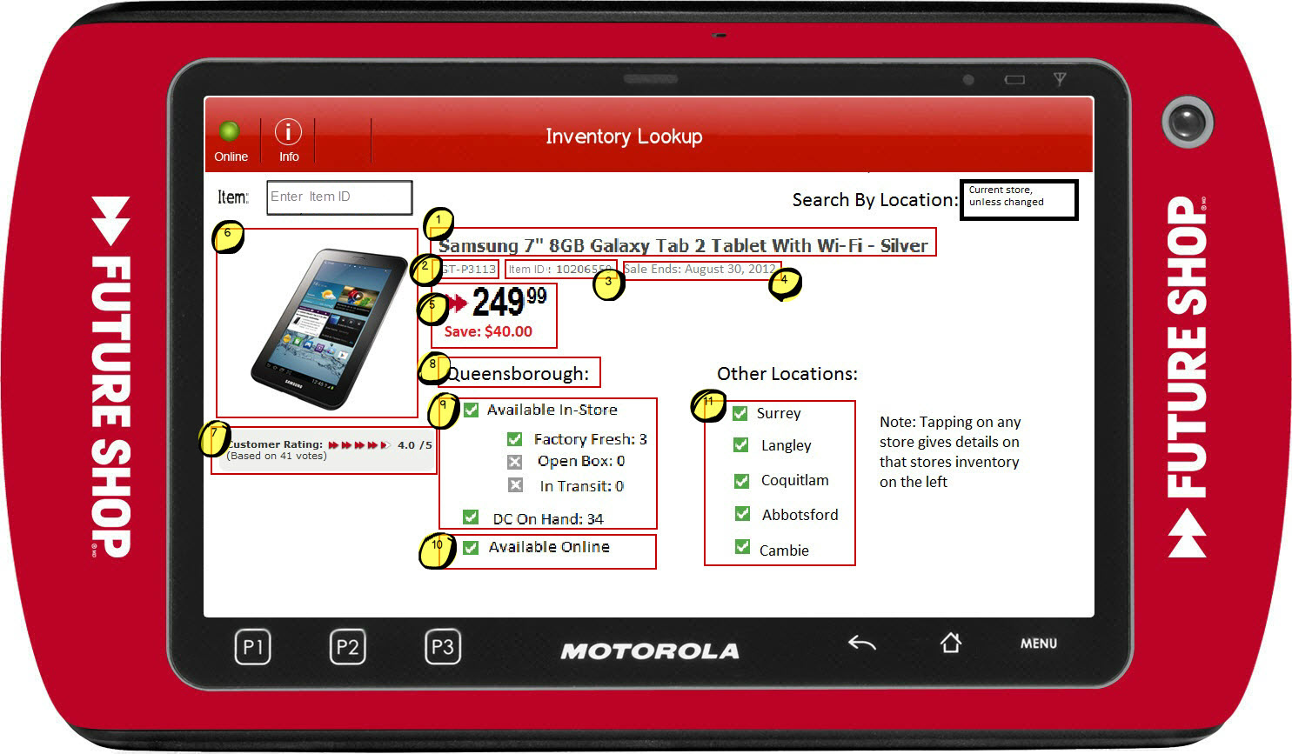

Figure 1: Inventory Lookup Details

### Instruction Text

|  |
| --- |
| **Instructions** |
| Inventory Lookup |

### Navigation/Menu Key

|  |  |  |  |
| --- | --- | --- | --- |
| **Label** | **State** | **Next Screen** | **Notes** |
| Exit | Enabled | * Calling use case | None |
| Search | Enabled | * Item or Location not found or system times out: Unable to Retrieve Details * Results returned: Inventory Lookup Details | None |

### Data/Input Field

|  |  |  |  |  |  |  |
| --- | --- | --- | --- | --- | --- | --- |
| **Label** | **Editable** | **Req’d?** | **Data Type** | **Min**  **Length** | **Max**  **Length** | **Notes** |
| Item | Yes | Yes | Numeric | 1 | 30 | Enter item ID or UPC to search for products. Item can be manually entered or scanned in. |
| Location | Yes | Yes | Numeric | 1 | 5 | Default Location to be current store |
| (1) Product Name | No | NA | NA | NA | NA | See Data/Input Field – Continued section |
| (2) Model Number | No | NA | NA | NA | NA | See Data/Input Field – Continued section |
| (3) Item ID | No | NA | NA | NA | NA | See Data/Input Field – Continued section |
| (4) Sale End | No | NA | NA | NA | NA | See Data/Input Field – Continued section |
| (5) Price and Savings | No | NA | NA | NA | NA | See Data/Input Field – Continued section  Pricing details are for the current store. |
| (6) Product Image | No | NA | NA | NA | NA | See Data/Input Field – Continued section |
| (7) Customer Rating | No | NA | NA | NA | NA | See Data/Input Field – Continued section |
| (8) Location Name | No | NA | NA | NA | NA | See Data/Input Field – Continued section |
| (9) Inventory Counts | No | NA | NA | NA | NA | See Data/Input Field – Continued section |
| (10) Online Availability | No | NA | NA | NA | NA | See Data/Input Field – Continued section |
| Other Locations | No | NA | NA | NA | NA | Instructional text only. |
| (11) Other Locations | No | NA | NA | NA | NA | See Data/Input Field – Continued section |
| Note: <Details> | No | NA | NA | NA | NA | Instructional text only. |

### Data/Input Field – Continued

| **ID** | **Section** | **Interface Name** | **Data Location** |
| --- | --- | --- | --- |
| 1 | Description | MRF or  REST API – Product Service | MRF Database or ProductDetails/name |
| 2 | Model Number | MRF or  REST API – Product Service | MRF Database or ProductDetails/ModelNumber |
| 3 | Item ID | NA | Item ID for the input parameter details |
| 4 | Sale End Date | Future | Future |
| 5a | Current Selling Price | MRF | MRF Database  Price is the price for the current location and not for location that was entered in for the search criteria  If unable to retrieve price from MRF database, price is retrieved from the REST API – Product Service in ProductDetails/SalePrice and the system prints ‘Price not available in store’. |
| 5b | Savings | MRF | MRF Database  Savings is calculated based upon the price for the current location. The retail price and the unit price are used to determine the savings.  If unable to retrieve price form MRF database, the savings is calculated by retrieving the regular price and sale price from REST API – Product Service in ProductDetails/SalePrice and ProductDetails/RegularPrice. |
| 6 | <Product Image> | REST API – Product Service | ProductDetails/ThumbnailImage  If Image not available, display image not available. |
| 7a | Customer Rating | REST API – Product Service | ProductDetails/CustomerRating |
| 7b | Rating Base Value | NA | Use default value of 5 |
| 7c | Count of Ratings | REST API – Product Service | ProductDetails/CustomerRatingCount |
| 7d | <Rating Image> | NA | Display an image based upon the Customer Rating out of Rating Base Value |
| 8 | Store Name | NA or REST API – Locations Service | MRF Database or Locations/Location/Name |
| 9a | Available In-Store | Inventory Lookup Service | Check icon if at least one of the following has at least a quantity of 1 – Factory Fresh, Open Box, In Transit  X icon if Factory Fresh, Open Box and In Transit are all 0, NULL or not present |
| 9b | Factory Fresh | Inventory Lookup Service | Quantity: GetInvDetailsResponse/GetInvDetailsReturn/ Inventory/InventoryItemQty/ffQuantity  Check Icon if Quantity greater than 0  X icon if Quantity is 0 or NULL or not present |
| 9c | Open Box | Inventory Lookup Service | Quantity: GetInvDetailsResponse/GetInvDetailsReturn/ Inventory/InventoryItemQty/obQuantity  Check Icon if Quantity greater than 0  X icon if Quantity is 0 or NULL or not present |
| 9d | In Transit | Inventory Lookup Service | Quantity: GetInvDetailsResponse/GetInvDetailsReturn/  Inventory/InventoryItemQty/inTransit  Check icon if Quantity greater than 0  X icon if Quantity is 0 or NULL or not present |
| 9e | DC On Hand | Inventory Lookup Service | Quantity: GetInvDetailsResponse/GetInvDetailsReturn/ Inventory/InventoryItemQty/dcOnHand  Check Icon if Quantity greater than 0  X icon if Quantity is 0 or NULL or not present |
| 10 | Available Online | REST API – Product Service | Check icon if ProductDetails/Availability/IsAvailableOnline=true  X icon if ProductDetails/sku/Availability/IsAvailableOnline=false |
| 11 | <up to 5 Closest Stores> | REST API – Location Service | Locations/Location/Name – 5 closest  Check icon if Locations/Location/ProductsAvailability/ ProductAvailability/Availbility = Available for the sku (TBD if this is correct) or InfoNotAvailable  X icon if Locations/Location/ProductsAvailability/ ProductAvailability/Availbility = NotAvailable  If no data returned, display data not available |

### Reason Code

|  |  |  |
| --- | --- | --- |
| **Reason Code** | **Valid Values** | **Default Value** |
| None |  |  |

### Invalid Store

|  |  |
| --- | --- |
| **Description** | This message is displayed when the store number entered is not valid. Upon acknowledging the message the system returns to the Inventory Lookup Screen with focus in the store number field and the results page remains blank or prefilled with last successful search. |
| **Message** | Invalid Store |
| **Key prompt** | OK |
| **Notes** | Configurable message |

### Unable to Retrieve Details

|  |  |
| --- | --- |
| **Description** | This message is displayed when the item or location entered is not found in the system or if the application timed out waiting for a response. Upon acknowledging the message the system returns to the Inventory Lookup Screen. |
| **Message** | Unable to retrieve item details. |
| **Key prompt** | OK |
| **Notes** | Configurable message |

# *Business Sign Off*

|  |  |  |
| --- | --- | --- |
| **Name** | **Organization** | **Date** |
| <Name of signer> | <Organization of signer if applicable> | <date of sign off> |

# *Revision History*

|  |  |  |  |
| --- | --- | --- | --- |
| **Reviser** | **Revision** | **Date** | **Version** |
| Amy Lackas | Initial version | 10/08/2012 | 1.0 |
| Amy Lackas | Updates after internal review | 10/10/2012 | 1.1 |
| Amy Lackas | Added additional details around if the price is not available from the store database. Added assumptions around sign on credentials and if the application is launched when a transaction has started. | 10/12/2012 | 1.2 |
| Amy Byers | Updated document to match R8 requirements and added requirements matrix | 08/26/2014 | 1.3 |

# *Appendix : Source Documentation*

* Requirement Specification - XPOS

## Functional Requirements

| **ID** | **Category** | **Sub-Category** | **Description** | **Section(s)** |
| --- | --- | --- | --- | --- |
| 2.6 | Functions | Inventory Lookup | Should a user enter an inaccurate store number when performing an Inventory Lookup, an error message will be presented, informing the user that the store number is not valid. | * 2.3 Main Flow * 2.6.1 Special Offline Requirements * 4.1.7 Invalid Store |
| 2.6.1 | Functions | Inventory Lookup | A user will not be permitted to lookup inventory from the alternate brand (BBY/FS). Should a user attempt to enter a store number of the alternate brand, the invalid store number error message will appear. | * 2.3 Main Flow * 2.6.1 Special Offline Requirements * 4.1.7 Invalid Store |
| 2.6.2 | Functions | Inventory Lookup | Once the invalid store number error message is acknowledged, the user will be returned to the store number entry field and the results page will remain blank, or display previous successful results. | * 2.3 Main Flow * 4.1.7 Invalid Store |
| 2.6.2 | Functions | Inventory Lookup | When Inventory Lookup is launched, the default store will be the current store. | * 4.1.4 Data/Input Field |

# *Appendix : Glossary*

|  |  |
| --- | --- |
| **Term** | **Definition** |
| REST API | Representational State Transfer external interface to perform tasks such as retrieving product information, searching for products, and retrieving store locations. |

# *Appendix : Referenced Documents*

* AP364 Data Mapping _Canada_MPOS_R1_RSS_Inventory_Lookup_V1 0
  + Inventory Lookup Service
* Best Buy Canada API 2_1 DRAFT
  + REST API – Search Service
  + REST API – Product Service
  + REST API – Locations Service